History 1810E

Primary source document analysis

Table of Contents

Postcard 1

Manufacturing company 1

Postage stamp 2

Date stamps 2

Picture side 3

Verso 4

Correspondence side 4

Address side 4

Correspondence Analysis 5

Allan Line – S.S. Scotian 5

Greenwood, West Kootenay, British Columbia 6

William Evelyn Oliver 6

The Oliver Family 6

Military Service 7

Beyond the War 7

Judith Johnson and William’s relationship 8

Unanswered questions 8

Bibliography 9

Due Date: Dec 7th, 2016

Zaid Albirawi

[zalbiraw@uwo.ca](mailto:zalbiraw@uwo.ca)

250626065

# Postcard

## Manufacturing company

The postcard’s manufacturing company was Novelty Manufacturing and Art Printing Co., Montreal. Prior to the Great War, Novelty Manufacturing was mostly known for their view cards that featured Canadian landmarks. However, during the war, it opted to depict the allies’ heroics on the Western Front.

A sample of Novelty Manufacturing’s postcards before the war:

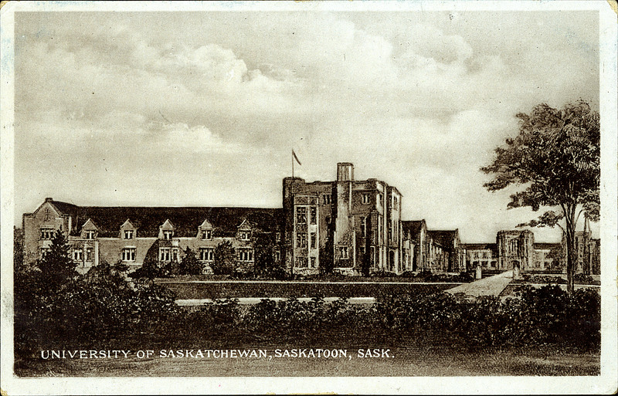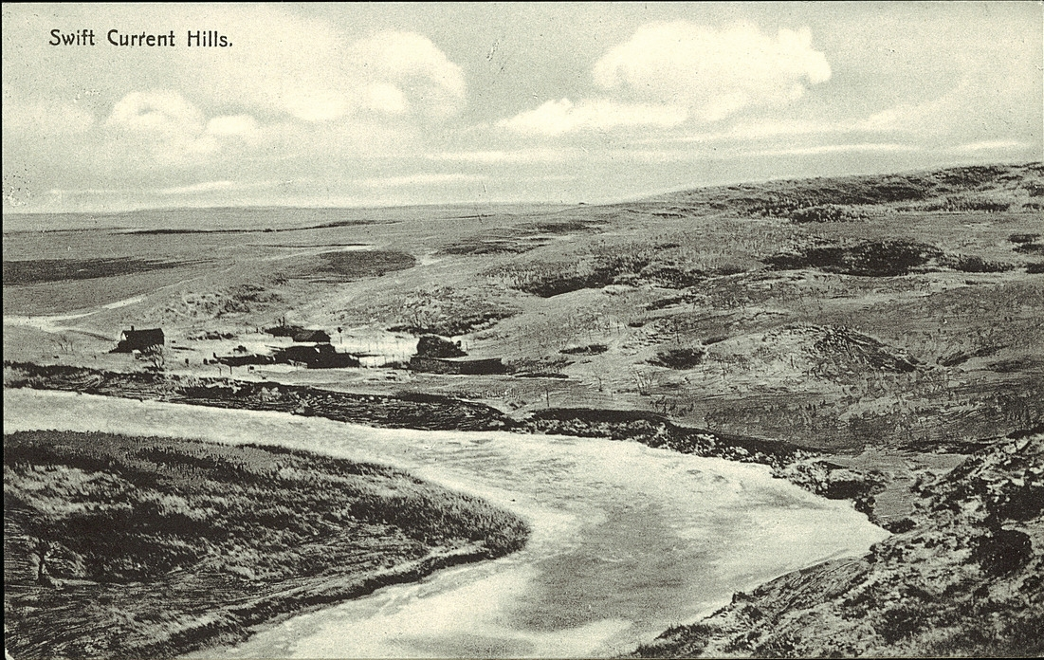

A sample during the war:

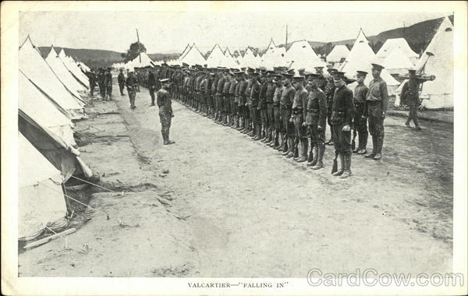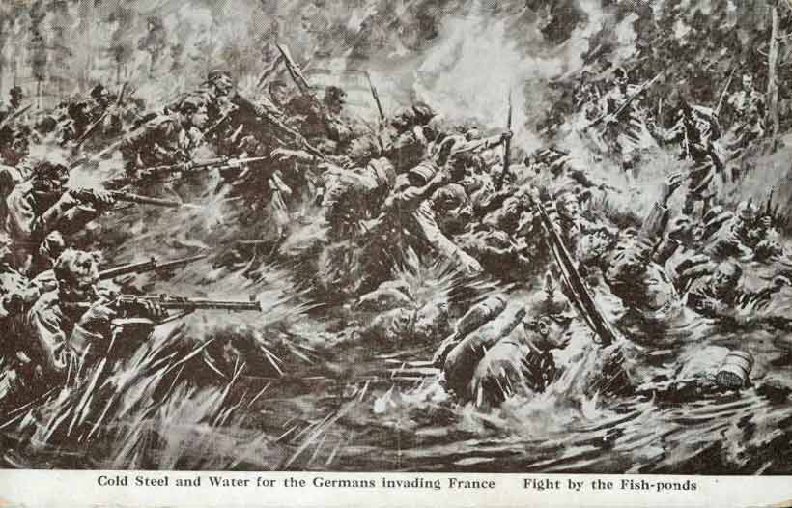

## Postage stamp

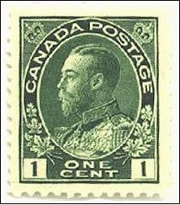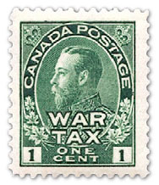The stamp presented on the postcard, left most, is a one cent Canadian postage stamp with the picture of the British Emperor. The right most stamp is a war tax stamp that was introduced in 1915 to accommodate for the war’s expenditures and is usually confused with the postcard stamp.

## Date stamps

Quebec post office at 2 PM, Sep 30th, 1914

British Columbia post office, Oct 5th, 1914

The time elapsed between the date stamps seems reasonable when considering that the postal services were using the Canadian Pacific Railway to deliver the postcards from the Quebec postal office to the British Columbia postal office. However, the date that the postcard was delivered to its intended recipient is unknown.

## Picture side

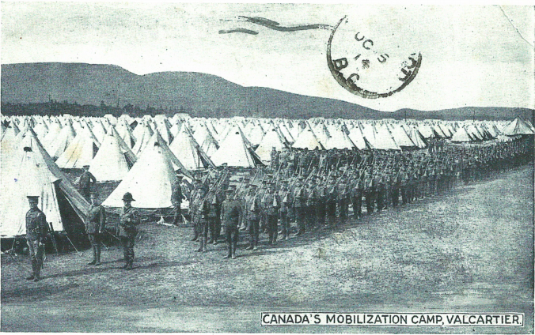

**Canada’s mobilization camp, Valcartier**

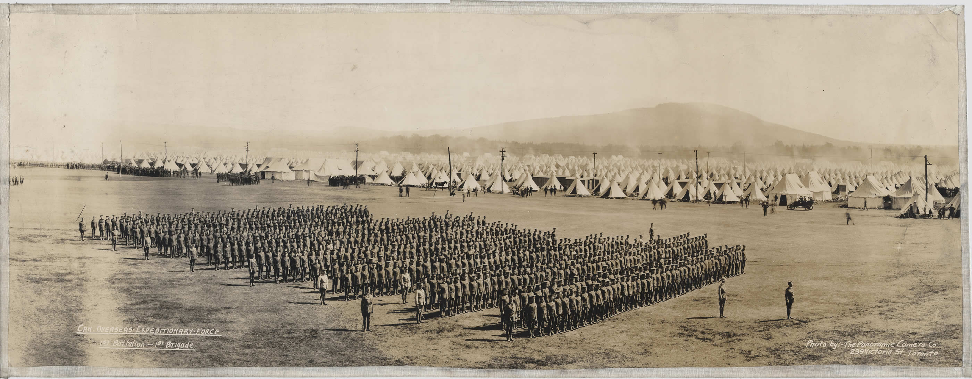

Valcartier was established at the onset of the First World War as the training camp for the Canadian Expeditionary Force(CEF). The camp was located in Saint-Gabriel-de-Valcartier, Quebec, hence the name Valcartier. The camp trained around 32,000 CEF soldiers in the First World War. And it is now a part of the Canadian Forces Base Valcartier.

## Verso

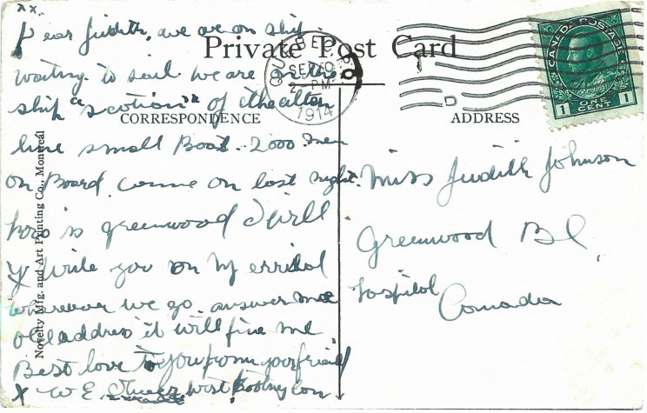

### Correspondence side

“Dear Judith, we are on ship waiting to sail. We are on the ship ‘Scotian’ of the Allan Line small boat. 2000 men on board. Came on last night. How is Greenwood? I will write you on my arrival wherever we go. Answer me * old address it will find me. Best love to you from your friend. W E Oliver, West Kootenay County.”

**Note:** ‘*’ refers to the name of the place where William was staying before setting sail to France. However, the name is not readable, hence, replaced with a ‘*’.

### Address side

**“**Miss Judith Johnson,   
Greenwood British Columbia,

Canada”

# Correspondence Analysis

The postcard is dated September 30th, 1914 which indicates that Private Oliver was a part of the Canadian First Division that arrived in France in December 1914 as Canada’s first involved units in the First World War.

The postcard message carries an update from Private William Evelyn Oliver to his friend Judith Johnson. Private Oliver communicates that he boarded the ship “Scotian” of the Allan Line and is on his way across the Atlantic to the Western Front. He also provides Judith with an address to write to while he is overseas.

## Allan Line – S.S. Scotian

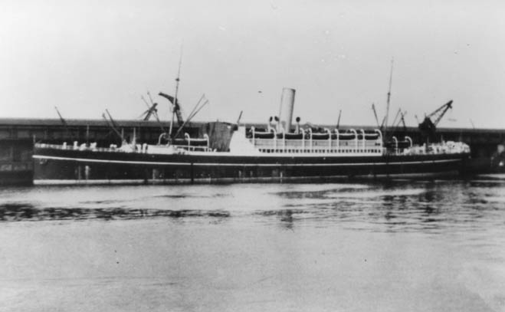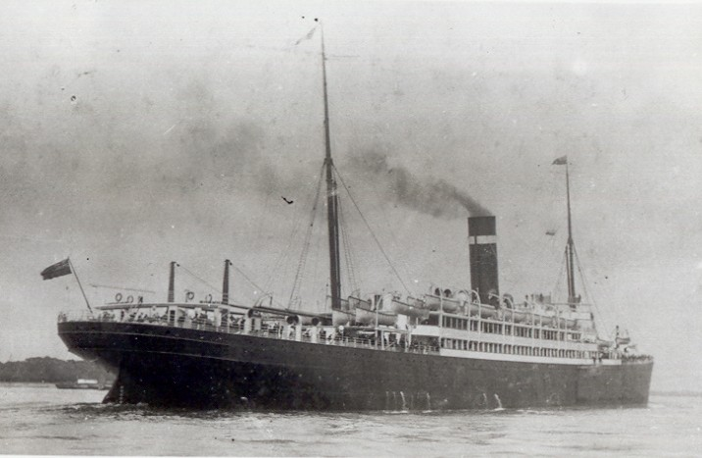

The Allan Line, founded in 1854, was a shipping company that was widely known for goods’ and passengers’ transportation. However, it was arguably best known for its contract with Royal Mail between Britain and North America. Royal Mail is, until this day, considered one of the United Kingdom’s largest postal services. Allan Line owned a fleet of the steamers, one of which is the S.S. Scotian. The Scotian was 515.3ft x 59.8ft in dimensions which is one of the bigger ships in the Allan Line fleet. In 1914 the Scotian was employed as troopship transporting the CEF soldiers to the shores of Europe.

**Discussion:** William Oliver referred to the Scotian as a “small boat.” However, the above pictures and facts indicate otherwise. Could he have been on another ship? Maybe the Scotian was considered a small boat if compared to some of the other ships in the troopships’ fleet.

## Greenwood, West Kootenay, British Columbia

Greenwood is a small city in the West Kootenay County of British Columbia. 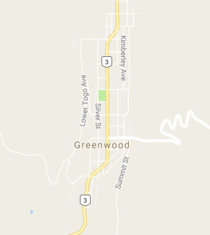It is, in fact, the smallest city in Canada with approximately 700 residence. The city was officially established in 1897, and per the census records of 1901, the Oliver family were located there then. In 1942, after the attack on Pearl Harbor, Greenwood was the home to around 1200 Japanese Canadian as a part of the Japanese Canadian internment.

# William Evelyn Oliver

William was born in New Westminster, British Columbia, on January 14, 1893. He moved with his family to Greenwood British Columbia between then and 1901. According to his attestation record, William was a rancher and was single prior to his enlistment.

## The Oliver Family

The census’ of 1911 captured the following information about the Oliver family before the Great War:

|  |  |  |  |  |  |  |  |
| --- | --- | --- | --- | --- | --- | --- | --- |
| Given Name | Relationship | Sex | Age | Given Name | Relationship | Sex | Age |
| Sydney | Head | M | 48 | **Eileen** | Daughter | F | 15 |
| Sophia | Wife | F | 48 | **James** | Son | M | 13 |
| John | Son | M | 20 | **Robert** | Son | M | 11 |
| William | Son | M | 18 | **Edward** | Son | M | 7 |
| Dollie | Daughter | F | 17 |

### Military Service

Sidney, William, and James all served in the CEF. It is unknown whether any other family members enlisted in the war as there are no records to indicate that. Both Sidney and William enlisted in 1914, while James had to wait until he is of age, 1916.

|  |  |  |  |  |  |  |
| --- | --- | --- | --- | --- | --- | --- |
| Name | Service # | Enlistment Date | Rank | Division | Obit | Battle |
| Sydney | 23428 | Sep 30th, 1914 | Lance Corporal | 7th Bn. | Apr 24th, 1915 | Ypres |
| William | 23429 | Sep 30th, 1914 | Private | 7th Bn. | Apr 24th, 1915 | Ypres |
| James | 931564 | Jun 1st, 1916 | Private | 54th Bn. | Apr 9th, 1917 | Vimy Ridge |

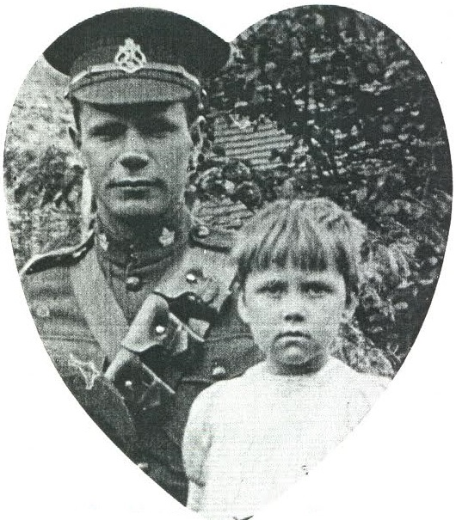

As shown above, all the Olivers who served in the military lost their lives in the war. They are honored in the Hartington War Memorial in the UK as Sydney was born there before migrating to Canada in 1890. Before his demise, James managed to visit Hartington on his way France and left a memorable photo with a young relative of his, shown on the right.

### Beyond the War

Through the census of 1921 provided by ancestry.ca, it was possible to track down some of the family members that survived the war. The Oliver family had left Greenwood sometime between James’ departure to the war and 1921 as they now live in Trail City, West Kootenay, British Columbia. While Sophia, Robert, and Edward were still living under the same roof, it seems that both Dollie and Eileen had gotten married.

## Judith Johnson and William’s relationship

Judith Johnson, born on March 25, 1886. Was a neighbor to the Olivers family according to the census of 1911. Judith was an inmate of the Benson house which was the house previous of the Olivers’ on the census list.

Despite the difference in age, William’s and Judith' relationship seem to be an intimate one. The postcard that William sent Judith was littered with hugs and kisses. If not, the content of the postcard suggests that the couple had been in communication since William’s departure to Valcartier which indicates that they are very close nevertheless.

# Unanswered questions

* What happened to John Oliver? Did pass away prior to the war? There were no records of enlistment for him. There were also no records of him in the 1921 census.
* What happened to Judith Johnson? Where did she come from? Judith had no records to her name in the 1901 census. She also had no records in the 1921 census.

# Bibliographys

Ancestry.ca. "1921 Census Of Canada." Accessed December 5, 2016. http://search.ancestry.ca/cgi-bin/sse.dll?db=CanCen1921&indiv=try&h=8228717.

Ancestry.ca. "1921 Census Of Canada." Accessed December 5, 2016. http://search.ancestry.ca/cgi-bin/sse.dll?db=CanCen1921&indiv=try&h=8226932.

Ancestry.ca. "1921 Census Of Canada." Accessed December 5, 2016. http://search.ancestry.ca/cgi-bin/sse.dll?db=CanCen1921&indiv=try&h=8228718.

Ancestry.ca. "1921 Census Of Canada." Accessed December 5, 2016. http://search.ancestry.ca/cgi-bin/sse.dll?db=CanCen1921&indiv=try&h=8228719.

Automated Genealogy. "1901 Census Of Canada." Accessed December 2, 2016. http://automatedgenealogy.com/census/DisplayHousehold.jsp?sdid=5096&household=27.

Automated Genealogy. "1901 Census Of Canada." Accessed December 2, 2016. http://automatedgenealogy.com/census/View.jsp?id=62031.

Automated Genealogy. "1911 Census Of Canada." Accessed December 2, 2016. http://automatedgenealogy.com/census11/View.jsp?id=59859.

Canada War Museum. "Pre-War Photographs - 1St Battalion At Valcartier | Canada And The First World War." Accessed December 4, 2016. http://www.warmuseum.ca/firstworldwar/objects-and-photos/photographs/pre-war-photographs/1st-battalion-at-valcartier/?back=114.

Card Cow. "Valcartier - Falling In." Accessed December 3, 2016. https://www.cardcow.com/419933/valcartier-falling-military-army/.

Diocese of Derby. "Hartington." December 3, 2016. http://www.derby.anglican.org/en/resources/ww1/sacrifice-remembered/ww1/hartington.html.

Greenwood City. "Smallest City In Canada, Kootenay BC, Historic Town | City Of Greenwood." Accessed December 4, 2016. http://www.greenwoodcity.com/.

Library and Archives Canada. "Item: OLIVER, SYDNEY (23428) - Library and Archives Canada." Accessed December 3, 2016. http://www.bac-lac.gc.ca/eng/discover/military-heritage/first-world-war/personnel-records/Pages/item.aspx?IdNumber=544068.

Library and Archives Canada. "Item: OLIVER, WILLIAM EVLYN (23429) - Library and Archives Canada." Accessed December 3, 2016. http://www.bac-lac.gc.ca/eng/discover/military-heritage/first-world-war/personnel-records/Pages/item.aspx?IdNumber=546797.

Library and Archives Canada. "Item: OLIVER, JAMES (931564) - Library and Archives Canada." Accessed December 3, 2016. http://www.bac-lac.gc.ca/eng/discover/military-heritage/first-world-war/personnel-records/Pages/item.aspx?IdNumber=551882.

Metro Postcard. "Metropostcard Guide To The Dominion Of Canada In World War One On Postcards." Accessed December 4, 2016. http://www.metropostcard.com/war7b-canada.html.

Norway Heritage. "The Allan Line." Accessed December 2, 2016. http://www.norwayheritage.com/p_shiplist.asp?co=allan.

Norway Heritage. "Scotian, Allan Line." Accessed December 2, 2016. http://www.norwayheritage.com/p_ship.asp?sh=scotn.

Norway Heritage. "Scotian, Allan Line." Accessed December 2, 2016. http://www.theshipslist.com/pictures/scotian.shtml.

Norway Heritage. "Scotian, Allan Line." Accessed December 2, 2016. https://home.cc.umanitoba.ca/~wyatt/pics/scotian-allanline.html.

Peel's Prairie Provinces. "Postcard 2931: Novelty Manufacturing & Art Printing Co, University Of Saskatchewan, Saskatoon, Sask. (Cca. 1910)." Accessed December 4, 2016. http://peel.library.ualberta.ca/postcards/PC002931.html.

Peel's Prairie Provinces. "Postcard 13241: Novelty Manufacturing & Art Printing Co, Swift Current Hills. (Cca. 1910)." Accessed December 4, 2016. http://peel.library.ualberta.ca/postcards/PC013241.html.

Postal History Corner. "Canadian Domestic Letter Rates 1867 To The Present Day." Accessed December 4, 2016. http://postalhistorycorner.blogspot.ca/2014/02/canadian-domestic-letter-rates-from.html.

Veterans Affairs Canada. "Sidney Oliver - The Canadian Virtual War Memorial - Veterans Affairs Canada." Accessed December 4, 2016. http://www.veterans.gc.ca/eng/remembrance/memorials/canadian-virtual-war-memorial/detail/1595043.

Veterans Affairs Canada. "William Evelyn Oliver - The Canadian Virtual War Memorial - Veterans Affairs Canada." Accessed December 4, 2016. http://www.veterans.gc.ca/eng/remembrance/memorials/canadian-virtual-war-memorial/detail/1595045.

Veterans Affairs Canada. "James Oliver - The Canadian Virtual War Memorial - Veterans Affairs Canada." Accessed December 3, 2016. http://www.veterans.gc.ca/eng/remembrance/memorials/canadian-virtual-war-memorial/detail/618302.

Wikipedia. "CFB Valcartier." Accessed December 4, 2016. https://en.wikipedia.org/wiki/CFB_Valcartier.

Wikipedia. "Allan Line Royal Mail Steamers." Accessed December 4, 2016. https://en.wikipedia.org/wiki/Allan_Line_Royal_Mail_Steamers.

Wikipedia. "Royal Mail". Accessed December 5, 2016. https://en.wikipedia.org/wiki/Royal_Mail.